Members,
I hope this email finds you well and I wish you all a blessed New Year. The following is a high-level summary of the FY26 National Defense Authorization Act (NDAA), S. 1071, which the President has now signed into law. This conferenced legislation, released on December 9, 2025, represents a compromise between the House and Senate versions passed in September and October, respectively, following negotiations involving congressional leaders and the White House. It authorizes $901 billion for national defense programs, with a strong emphasis on enhancing naval capabilities, acquisition reforms, and strategic priorities to equip warfighters efficiently and cost-effectively.
Key Highlights:
- Shipbuilding and Naval Procurement (Title I): The bill allocates $26 billion for shipbuilding and conversion, supporting:
  - The third Columbia-class Ballistic Missile Submarine and advanced procurement for future submarines.
  - One Virginia-class Submarine and advanced procurement for future ones.
  - Advanced procurement for DDG-51 Arleigh Burke-class Destroyers.
  - Full funding for the Ford-class Aircraft Carrier program.
  - One anti-submarine warfare auxiliary ship (T-AGOS).
  - Two Ship to Shore Connector landing craft.
Adjustments in procurement charts reflect increases in funding and quantities for certain programs, such as additional Virginia-class submarines and DDG-51 destroyers, to bolster fleet strength.
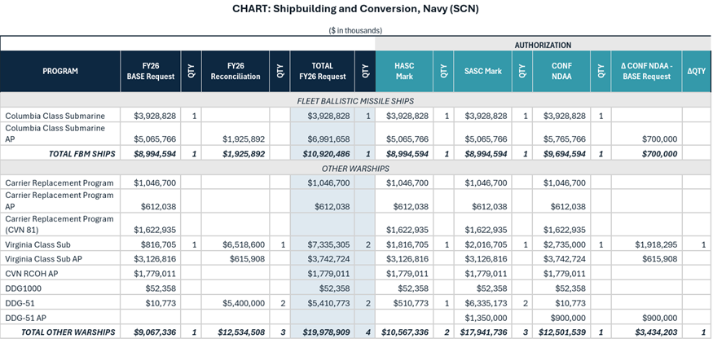
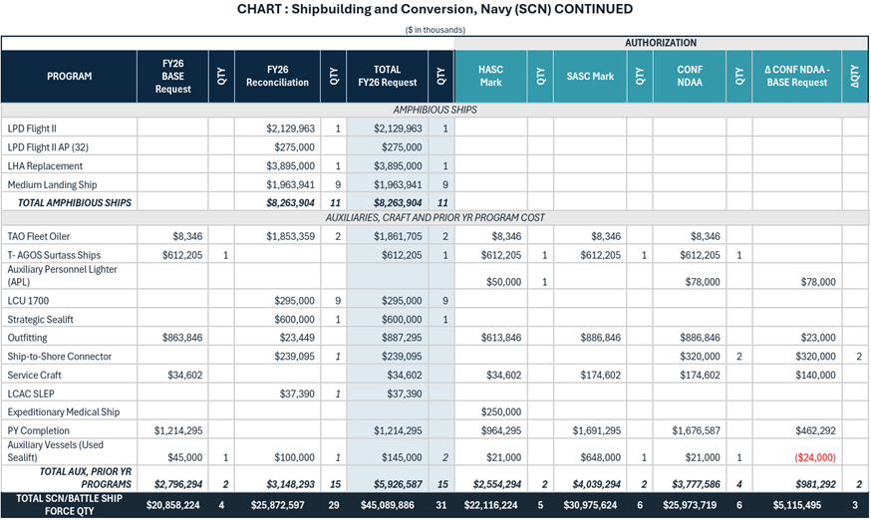
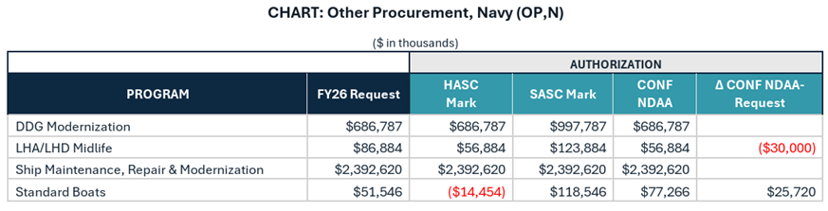
- Research, Development, Test & Evaluation (Title II): Authorizes funding for Navy RDTE with adjustments for programs like digital engineering standards alignment (Sec. 221), focusing on innovation and contested logistics.
- Operation and Maintenance (Title III): Includes provisions for logistics and sustainment, such as designating officials for global contested logistics (Sec. 334), roles for surface vessel readiness (Sec. 337), and enhancements to the Shipyard Infrastructure Optimization Program (Sec. 339).
- Acquisition Policy and Management (Title VIII): Emphasizes reforms to streamline processes, including assumption of uninsurable risks (Sec. 801), addressing technical data insufficiencies (Sec. 805), repeals of outdated laws (Sec. 811), workforce development improvements (Sec. 821), supply chain resilience (Sec. 832), and prohibitions on certain procurements (Sec. 843).
- Department of Defense Organization (Title IX): Covers management changes, such as removal processes for Joint Chiefs and combatant commanders (Sec. 911) and limitations on command modifications (Sec. 916).
- General Provisions (Title X): Addresses naval vessels and shipyards, including amphibious warfare ship requirements (Sec. 1011), Navy Senior Technical Authority (Sec. 1013), maintenance allocations (Sec. 1015), and a pilot program for automated shipbuilding (Sec. 1021).
- Space, Strategic Programs, and Intelligence (Title XV): Includes missile defense provisions like design of instrumentation range safety vessels (Sec. 1656).
- Acquisition Reform (Title XVIII): Establishes portfolio acquisition executives (Sec. 1802), amends life-cycle management (Sec. 1803), and modifies commercial product acquisitions (Secs. 1821-1824).
- Maritime Administration (Title XXXV): Notes provisions not adopted, such as clarifications on port infrastructure and cargo preferences.
The legislation also incorporates report language on various topics, limitations on certain programs (e.g., unmanned surface vessels), and exclusions of some proposed provisions like reductions to Army prepositioned stocks.
Now that the authorization legislation is complete, we will also need passage of the corresponding Appropriations legislation to provide the actual funding for these programs.
Marcel Becker
Chairman, PSDSRA Strategic Affairs Committee

