Fall Protection & Scaffolding Safety
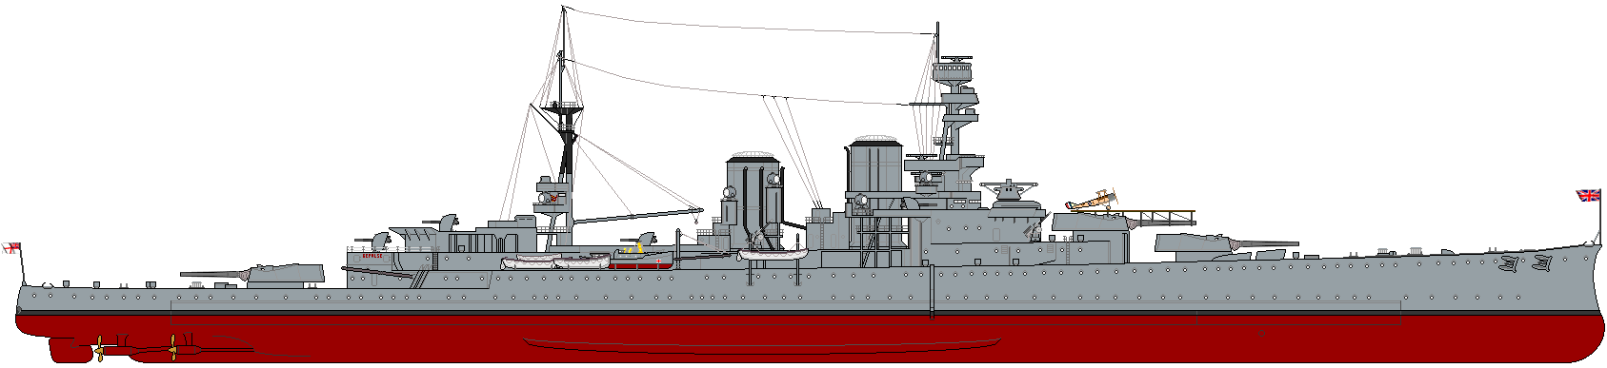
This Photo by Unknown Author is licensed under CC BY-SA

Shipyard Safety Workshop
Fall Protection & Scaffolding
Thursday, March 14, 2019, 7:00am–8:30am
Action Cleaning Corp. 1668 Newton Ave. SD, CA

Free Workshop, No Cost
Introduction:

Shipyard employees are often required to work in dangerous environments that may include fall hazards. Accidents involving elevation equipment such as ladders, scaffolds, and aerial lifts are often serious, even fatal. Potential hazards occur from falling through deck openings and open holes as well as falls from ladders and scaffolds.

Fall hazards are a leading cause of shipyard fatalities!

The purpose of this class is to support you in working aboard a ship safely as well as provide awareness on what you should do in case of an emergency.
Topics
      - Working Above Ground Rules
      - Working on Ladders
      - Working on Scaffolds
      - Quizzes

Target Audience: All employees new to working on board a Navy Ship
Class Length: 1.5 Hours

Contact Jaymes Green at SanDiegoShipRepair@gmail.com or 619-549-5439 to reserve seats for this beneficial FREE workshop. Space is limited.

