2018 Port of San Diego Ship Repair Association
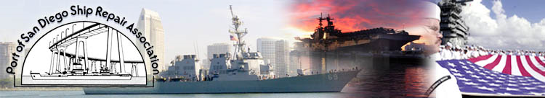
We are proud to offer the following free safety training to you:

Shipyard Machinery & Portable Power Tool Safety
Wed., May. 23rd, 2018, 7:00am–10:30am
Cal Marine, 2049 Main St. San Diego, CA 92113

Introduction:
Machinery and machine guarding hazards, including portable power tool hazards, are likely faced by every single ship yard worker who works on ships and/or in the shop. These machines are vital when fixing ships, however, the hazards they create can be devastating. Crushed hands and arms, severed fingers, blindness -- the list of possible machinery-related injuries is as long as it is horrifying. There seem to be as many hazards created by moving machine parts as there are types of machines. Safeguards are essential for protecting ship yard workers from needless and preventable injuries.

Course Purpose:
At the completion of this workshop it is expected that all trainees will be able to better identify, evaluate and control hazards associated with shop machinery and portable power tools.
.
Specific Topics:
- Machine Guards and Devices
- Specific Shipyard Shop Machine Hazards and Solutions
- Portable Power Tool Hazards
- Portable Power Tool Precautions
- Specific Shipboard Portable Power Tool Hazards & Solution

Target Audience:
This training course focuses on machinery often found in ship building and repair shops as well as the portable power tools most commonly used on board. The target audience is any shipyard worker who works in a shop or onboard the ship. Contact Jaymes Green at SanDiegoShipRepair@gmail.com or 619-549-5439 to reserve seats.

