Maritime Industry Safety Program
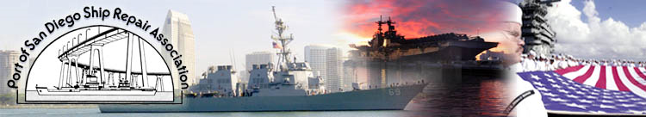

“Power Tool and Machinery Safety Training”

Beginning in early 2018, funded by an OSHA Susan Harwood training grant, the Port of San Diego Ship Repair Association (PSDSRA) will be implementing a vital safety training program. The safety training program will focus on the hazards and safety measures associated with machinery and machine guarding hazards including portable power tools used onboard. The training will be presented to a target audience through the following three methods:

- Train-the-Trainer - Safety Representatives from qualifying companies will be trained on the safety topics and present the information to their workers.

- Onsite workshops - Certified trainers will present the machine safety training onsite at companies throughout the San Diego region.

- Open Public Workshops – The safety training course will be presented on regular monthly scheduled dates at a location near the shipyards.

The PSDSRA strives to continually increase awareness and education in the San Diego region. The training program in 2017 allowed hundreds of shipyard workers to receive vital training. This grant-funded training is another example of the Port of San Diego Ship Repair Association’s effort to enhance maritime safety practices throughout the port. To participate in this training opportunity, contact Jaymes Green for more information at SanDiegoShipRepar@gmail.com

